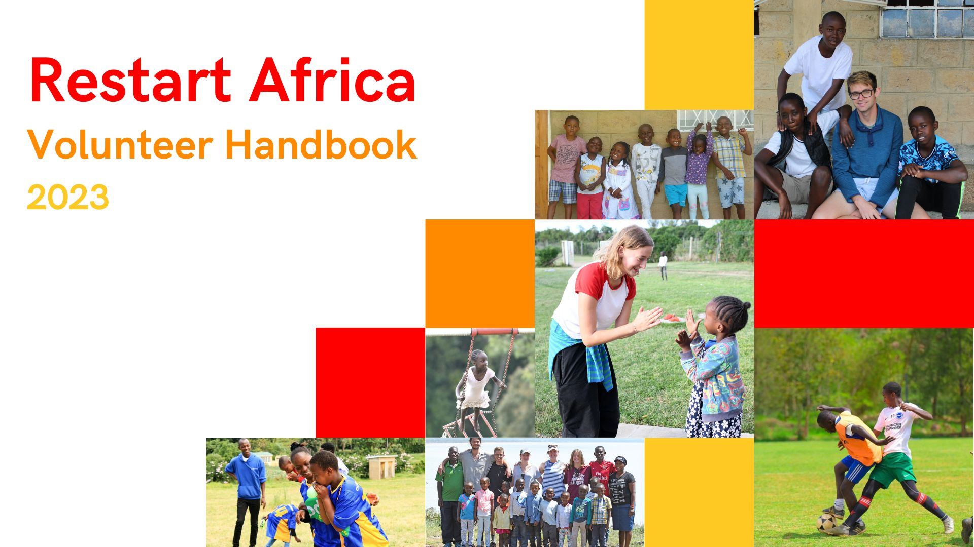

The Handbook

First of all, welcome to Restart Africa!! We hope your experience with us is insightful, and educational but, most importantly, fun!

The Volunteer Coordinator will hopefully have given you all the info you need about travel to Kenya and the volunteer admin, what THIS handbook is here to do is provide additional information to hopefully answer questions and concerns you and your family may have.

This handbook will touch on the following:
- The History of Restart
- The Overview of the Volunteer Program
- Health, Security, and Safeguarding
- Day to Day and Travel!

Within the handbook, you will read various testimonies from previous Restart volunteers sharing some of their favourite moments and pieces of advice.

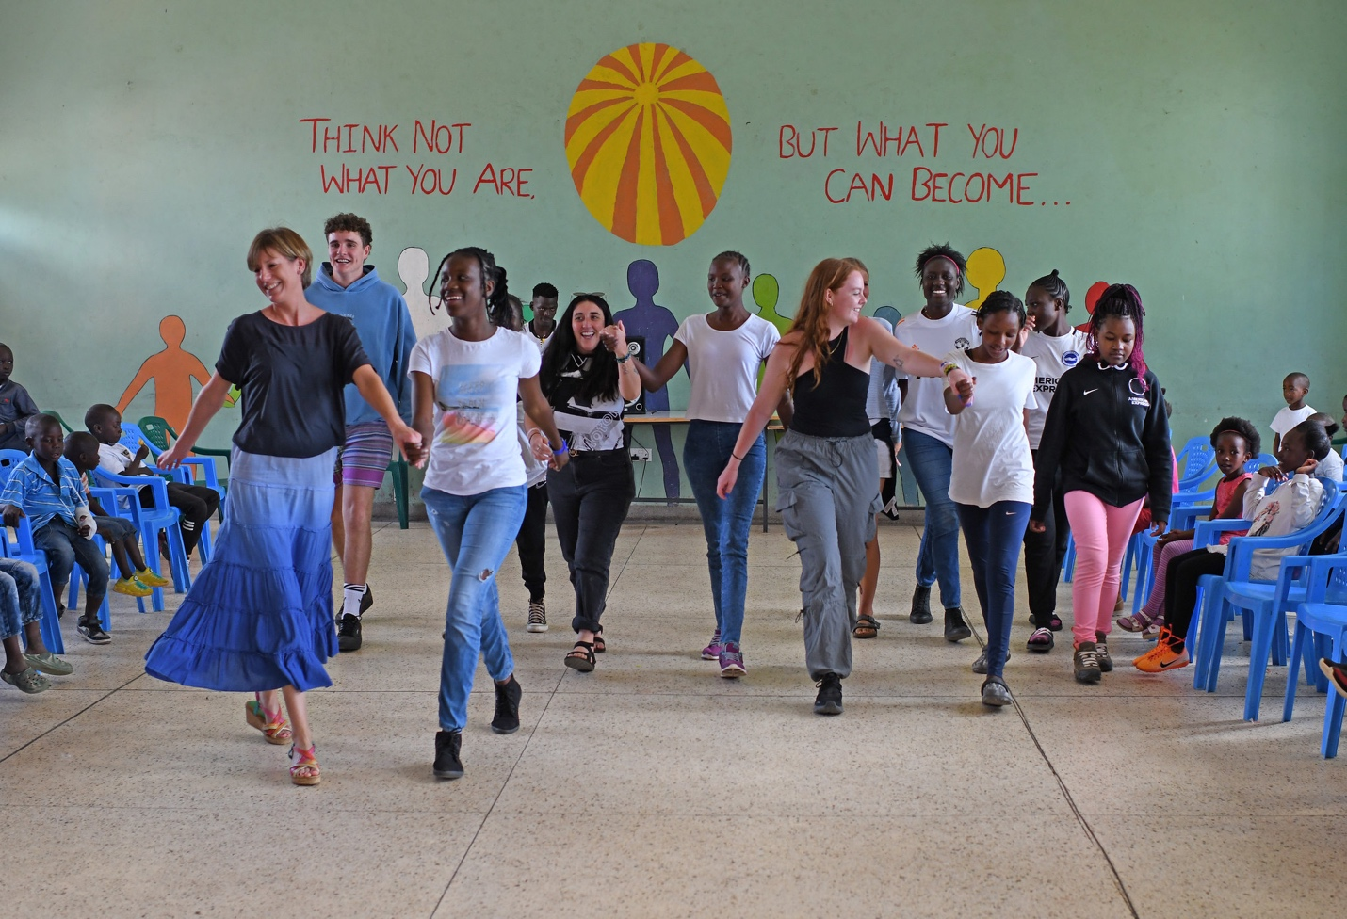
HISTORY OF RESTART AFRICA

Restart Africa was founded by Mary Coulson in 2007. Following Kenya’s general election in 2007, Mary noticed a concerning increase in the number of homeless children throughout the streets of Gilgil and felt called to help. Mary knew that these children were at acute risk of starvation, violence, drugs, and sexual abuse. In 2007, Mary opened the first Restart Centre in the town of Gilgil. The Centre was a modest rental property and it provided refuge to 6 boys. Over the years, the number of children in the care of Restart grew to over 100. In 2014, Restart moved to a beautiful new premise in Langalanga which provides the children with shelter, food, education, love, and stability.

The sustainability and longevity of Restart Africa were at the forefront of the newly built centre. Alongside boys’ and girls’ dormitories and nursery, the new centre has classrooms, a fully stocked library, a dining hall, a music room, and laundry facilities. The new centre also includes a large sports field, playground, and Restart’s own agriculture project. The agriculture project provides the children with fresh and organic vegetables daily and allows them to have little “shambas' (farm) where they learn how to grow flowers and vegetables independently.

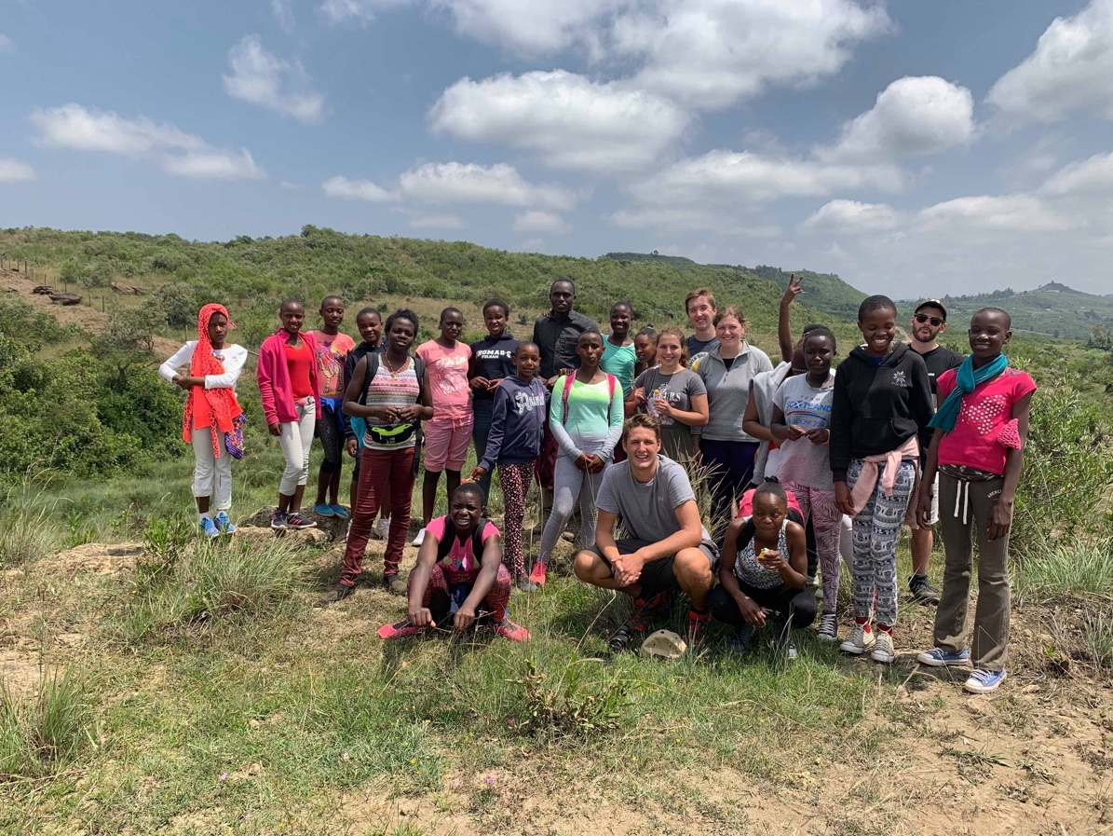

YOUR POINTS OF CONTACT

- Founder and Executive Director*
Mary Coulson MBE is the Founder and Executive Director of Restart Africa. Mary oversees and is responsible for all matters at Restart Africa.
Mrs. Mary Coulson: +254 723 786008

- Volunteer Coordinator*
Mr Abdi is the volunteer coordinator and is responsible for the volunteer program at Restart. He is the first point of contact throughout your stay. Please let them know if you have any questions, or concerns, or need any supplies well you are at the Centre.
Email: volunteer@restartafrica.org
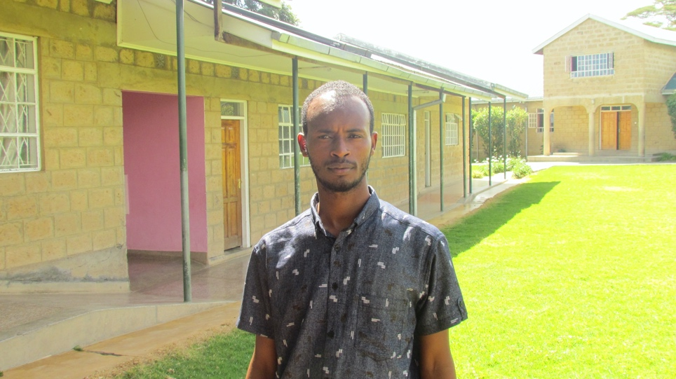

If you wish to know more about our staff, please visit the website where you will find a list of all of our staff and their role within the trust (and don’t be afraid to say hi!)

OVERVIEW OF THE VOLUNTEER PROGRAM

Where it all began…

In 2009, Restart welcomed its first volunteer and since has hosted over 100 volunteers, many of whom visit year after year. Volunteers have had an everlasting impact on the children at the centre, the children began to have ambitions and talk about their future education and training. Bringing volunteers from overseas has allowed the Restart children to expand their view of life and gives them hope for the future. Restart has a great impact on volunteers as well. It helps shift your life perspective and will teach you things you never knew about yourself.

Arriving in Kenya and Restart

Upon arrival, you will be picked up by Restart’s highly trusted taxi driver, Kim. Kim has safely transported volunteers to and from Restart for over a decade, and will treat you to your first Kenyan Breakfast if you arrive in the morning! He is a big fan of his chai!

Kim’s Number: +254 727 316094

There are designated volunteer flats (apartments) located within the compound. The flats are:
- located near the shambas and sports field, just a few hundred meters up from the main buildings, giving volunteers the space to decompress and socialize.
- equipped with a bedroom, living area, small kitchen, and a bathroom with a shower that (usually) has hot water.
- Set up with a variety of furniture and kitchen supplies, such as fridges, hot plates, a kettle, and sofas.
- The flats have wifi (sometimes patchy), please ask the volunteer coordinator for the password.

If you arrive at the centre during the day, you will be met by a staff member who will help you get settled into your flat. If you arrive during the nighttime, your flat will be prepared so you can get a good night's sleep. On your first day, you will be given a tour of the compound and will meet with the volunteer coordinator to ensure you have all the supplies you need.

Your first couple of days can be a little overwhelming as you adjust, but do not worry. The staff and children are very welcoming and will make you feel at home right away.

While it is not guaranteed there will be other volunteers there during your stay, Restart works hard to try to have at least 4 volunteers at a time. If at any time you have questions or concerns, please let the volunteer coordinator know, they are there to help and ensure you have the best experience.

It is expected that you will eat meals with the children, but you can also cook for yourself
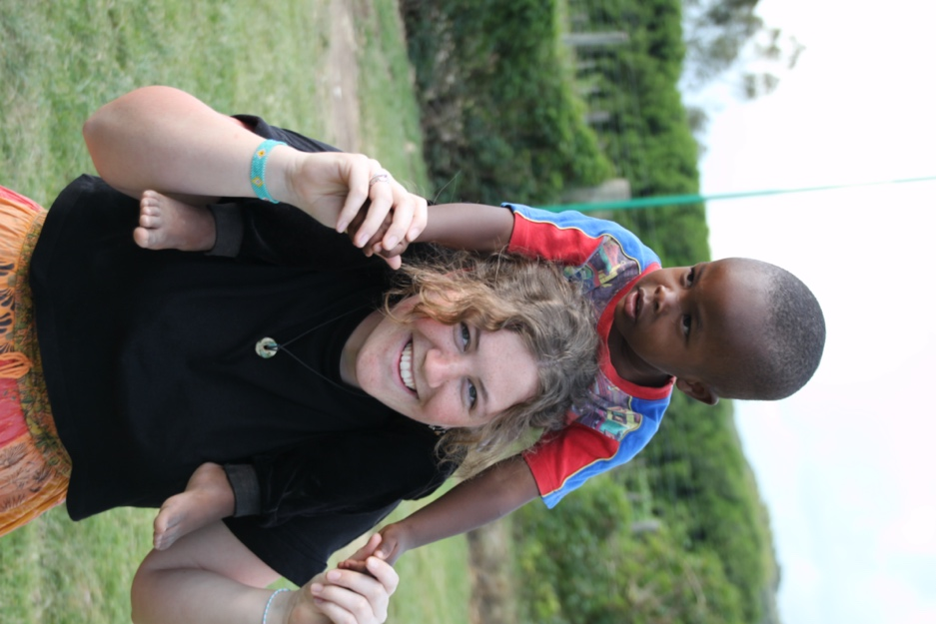
Once you’re settled…

As a volunteer at Restart, you will act in a supportive role at the centre, whether that's assisting the children with schoolwork, playing on the field, or helping in the kitchen. Depending on which time of year you are at the centre will depend on your schedule.
- Holiday periods: your days will be busy spending time with the children.
- School Term: you might go to school with the younger children, work in the shambas or assist the Restart staff as required.
- If you are bringing with you some skills, such as music, sports, teaching etc, let the volunteer coordinator and we will see if we can get you to utilize your skill with the kids!

Each week you and the other volunteers will meet with the volunteer coordinator to create a schedule for the upcoming week. It is recommended that if you are running low on supplies (toilet paper, water, etc) you bring them up in these weekly meetings so the staff can replenish your supplies before you run out.

Each week you can have one day off (optional if you’re too invested in the centre!), where you can eat some delicious food, explore the surrounding areas, and get to know the volunteers. Later in the handbook, you’ll find a recommended list of places to visit on your day off.

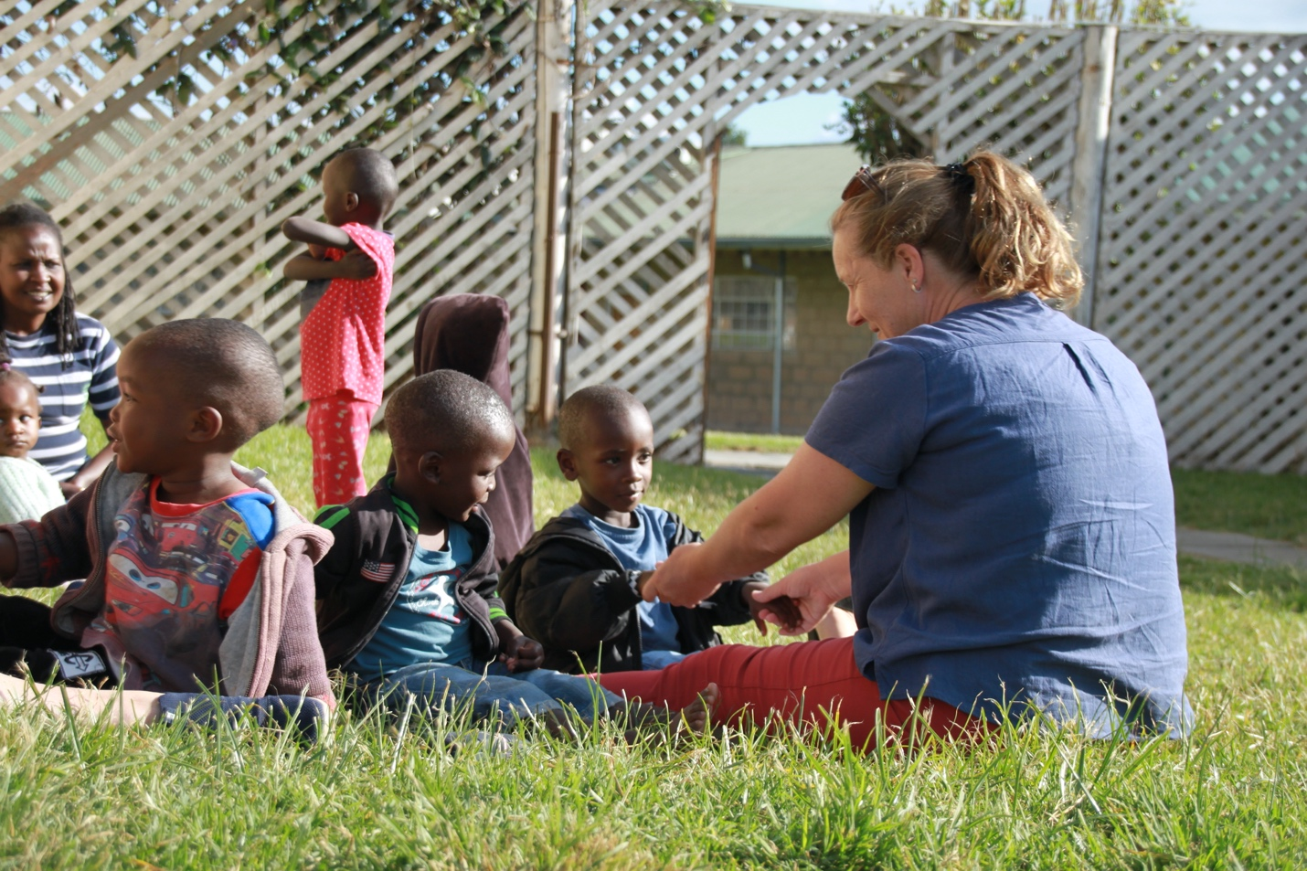

HEALTH, SECURITY AND SAFEGUARDING

Health and safety are the top priority at Restart for all staff and children:
- The entire compound is safely secured with an electric fence and is patrolled 24/7 by a team of “askaris” (guards).
- All the flats will have a lock and key and it is strongly recommended you lock your door when you leave and at night. The staff and children do not generally go down by the volunteers' flats unless to clean them, but it is still good practice to keep money, valuables (and sweets) secured when you leave your room.
- You will be provided with clean, filtered water in jugs to drink during your stay. When traveling outside of the centre unless you are 100% sure it is safe, you should ONLY drink bottled water.
- The centre is located at an elevation of approximately 1981 meters (6500 feet) above sea level. As a result of the high elevation, you should ensure you hydrate well before arriving and throughout your stay at Restart. Headaches are common for the first couple of days if you are from low lying areas!
- Due to the high altitude, Restart is not a malaria zone. Therefore antimalaria medication is not required. There are still plenty of mosquitoes around, especially at night so it's recommended you use the supplied bug net and bug repellent.
- If you plan to travel throughout the rest of Kenya, you should consult with your doctor about taking antimalarial medication.
- Restart is equipped with multiple basic first aid kits, if at any point you require one, please ask the Restart manager or another staff member.
- Bosma Chemist in Gilgil has a selection of common over-the-counter medication and basic medical supplies.

If you require additional medical care, please speak with the manager or Mary, who will be able to help.

“The children will teach you more than you ever thought possible. They will teach your heart to love, your perspective to grow, and your imagination to run wild. Come to Restart, not only to teach, but to learn.” - Kati Kelsey, volunteered in 2011, 2012 & 2015.

DAY TO DAY AND TRAVEL

One of the best parts about being a volunteer with Restart is no day is the same. One day you’ll be spending hours preparing lunch with the older children, and other days you will be chasing the nursery kids around the sports field. You certainly will learn something new each day, whether that’s a new card game, dance move, or word in Swahili, the children are always eager to teach new volunteers.

Please do not be afraid to share your hobbies and talents with the children, they love to learn, especially from our volunteers. Below is a list of activities past volunteers have done with the children to give you an idea:

- arts and crafts - the younger children love to colour
- talent shows
- yoga in the sports field
- morning runs
- volunteers cook dinner night / bake cookies
- sports tournaments
- a reading club

If you have an idea of an activity, you’d like to do with the children speak with the volunteer coordinator.
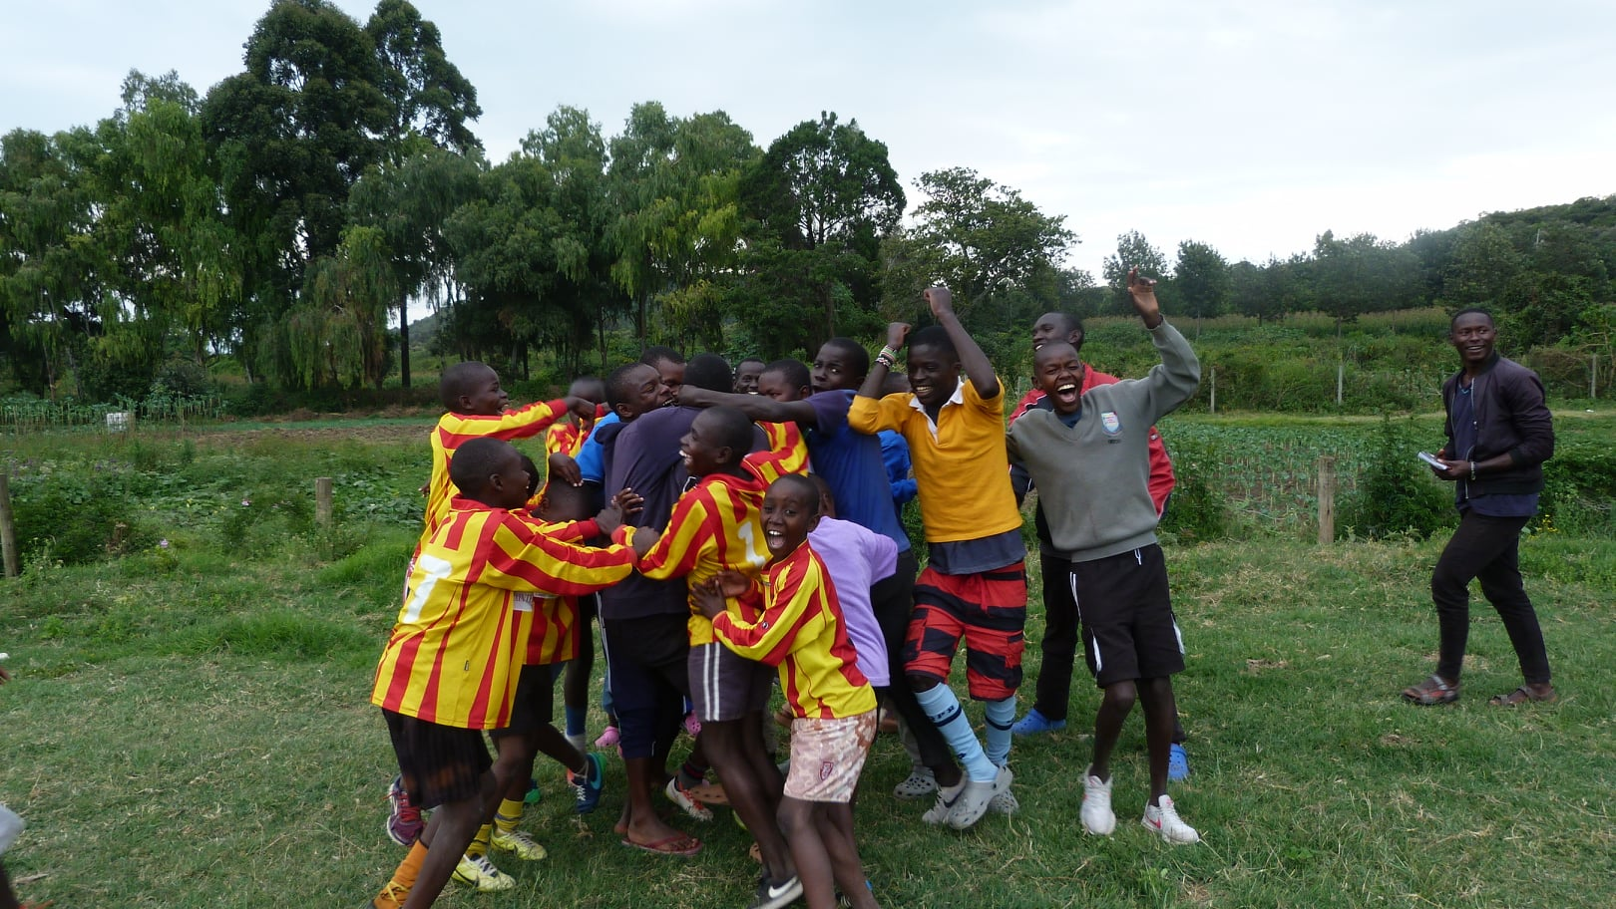
“A highlight of going to Restart for me was seeing, feeling, and experiencing the power of love. Seeing a new kid’s growth at Restart over just a couple of weeks, as he went from silent, scared, and hopeless to smiling, laughing, and loving his new family was one of the most amazing experiences of my life.” - Jess Lyon, volunteered in 2022

“In 2019 Pat and I were doing craft work with a number of young ones when Mary and the British High Commissioner came by and heard us all singing “There’s a whole in my bucket dear Liza”, we did know they were outside, and it’s a lovely memory” – Margaret Butler

How do I know if Restart is for me?

As a volunteer, spending time with the children and at the centre must be a priority.
If you are hoping to come to Restart to indulge in the nightlife every night, Restart might not be the place for you.
It is important that you enjoy spending time around children, as most of your time spent will be working with children of all ages.
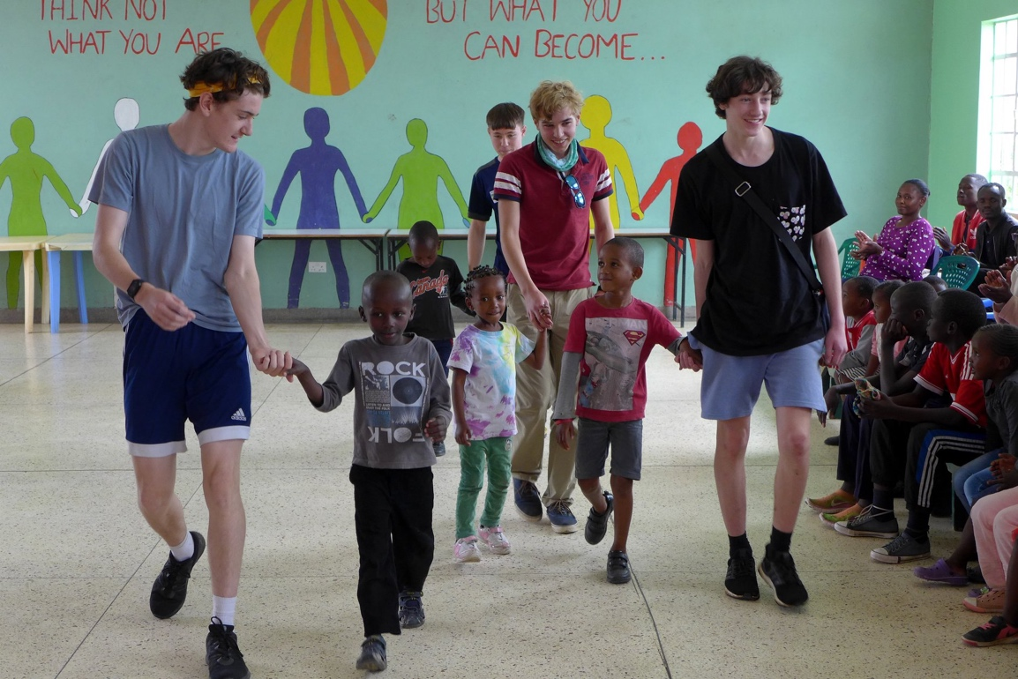

Going Off Site:

When you are planning to go off-site, it is important you let the volunteer coordinator and manager know your plans. Please DO NOT visit local bars and nightclubs without getting advice first.

Getting around:

Boda Bodas (motorbikes) are a common form of transport in Kenya. If you decide to take a boda boda into town, please wear a helmet, and choose your boda drivers wisely. It should cost no more than 200 KES one way from Restart to Gilgil town.

You can also contact our taxi driver, Kim, and he can take you further afield. DO NOT get a Boda Boda on the main roads outside of Gilgil, only get the taxi.

You will be able to access ATMs in Gilgil, we recommend ABSA as it has the lowest transaction fees.

If you will be in Kenya for a length of time, we would recommend getting a SIM card through Safaricom to allow for texting and calls.

You can also set up an Mpesa account. This is a secure money transfer system exclusive to Kenya and it makes paying very easy! Please speak to the volunteer coordinator to help set up both the Mpesa and the SIM card.

Home Comforts:

As stated previously, you will be expected to eat with the kids often. However, we understand the need for home comforts!

Chawakas and EastMatt are the main grocery stores in Gilgil, they are both well-stocked and have most things you will need for some home cooking, breakfast, tea, toiletries etc.

You can also go to the local markets in Langalanga, these are not as well stocked as Gilgil but you will find your basic essentials (tea, milk, toothpaste) here and it is all within walking distance.

Gilgil Country Club

During your time at Restart, you may be invited to visit the Gilgil Club by Pembroke House School gap students. Please seek advice from Mary before going, it is not a cash bar, so we need to book you in ahead of time. Volunteers will not walk to and from the Gilgil Club at night.

Get your photos on the social media!!

We are looking to get YOUR photos on the facebook and Instagram as you have the insider perspective on day to day life with the kids. If you have any good photos from your days in the centre, particularly of any out of the ordinary events, then please send them over to our fundraising coordinator, Ben, back in the UK. He is a previous volunteer himself so he will be happy to hear your stories from the centre!

You can reach his whatsapp at: +44 7925 181260
Or his email: fundraising@restartafrica.org

If you have any questions for some previous volunteers, Ben and Bela would be happy to email or call to answer your queries!

Bela’s email is belaj103@gmail.com and she can answer your questions or organize a call to chat about her time at restart.

The same applies for Ben, his details are above.
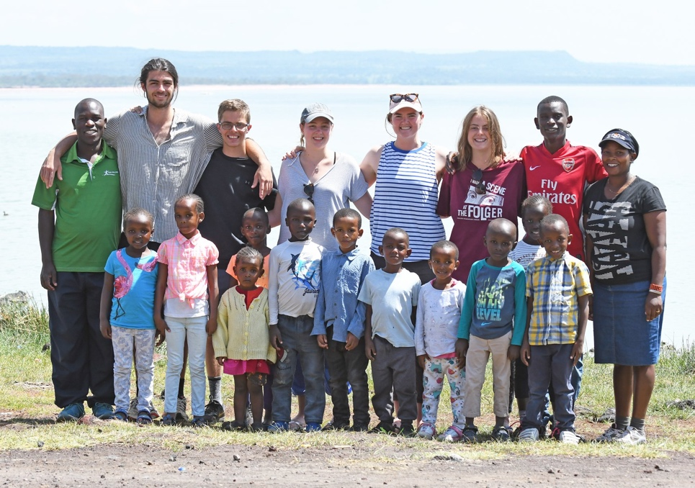

“Make sure to explore the local area! Gilgil itself is beautiful so don’t be afraid to go for a walk in to town and go up the local hill behind Restart. There is an amazing viewpoint that looks out over the rift valley and you can see for miles. Turn left when you reach the end of the Restart track and just keep going up until you reach rocks!” – Bela Jones, volunteered in 2019 & 2023 twice!

“Volunteering teaches you so much about yourself. You build so much emotional maturity being out here in Kenya and you learn the importance of care and love. My highlight has been simply been getting to know the kids and gaining their trust and companionship. There is nothing more rewarding than making one of these kids laugh!” – Ben Morgan, volunteered in 2017, 2019 & 2023.

NEARBY PLACES TO VISIT ON A DAY OFF

Hells Gate National Park – the only bicycle safari experience available in Africa! This is a chance to hop on a mountain bike (provided by the park) and see Africa’s great animals close up! About 1-hour drive from Restart
Contact: https://www.kws.go.ke/content/hells-gate-national-park

Camp Carnelleys - a campground with a delicious restaurant located beside Lake Naivasha, about a 1-hour drive from Restart.
Contact: info@campcarnelleys.com

Crescent Island - located on Lake Naivasha and only accessible by boat, Crescent Island is a wonderful place to spend the afternoon. You can walk along the island and see zebras, giraffes, and hippos.
Contact: visit https://www.crescentisland.co/

Mt Longonot- if you are looking for a place to go hiking, consider Mt. Longonot. It is just over an hour away and is a stratovolcano. The hike is challenging, but worth it!
Contact: longonotnp@kws.go.ke

Thomson Falls – Located on the edge of the Aberdare range, this waterfall is an amazing nature experience and has some lovely local restaurants where you can get tea or lunch!

There are many more places to visit, just ask Mary for any advice on the best tourist spots, we encourage you to explore Kenya.
EXPLORING KENYA?

If you are here for a long stay, or are looking to travel after your stay then Kenya is alive with amazing experiences and places to visit. Whether your thing is being on safari, hiking up some of the world’s highest mountains, or relaxing by the coast, Kenya has it all! Just ask Mary for her local knowledge on where the best spots are!

DONATIONS

If you would like to bring donations from home to Restart, the following items are always in high demand:
- sneakers/shoes
- school supplies
- hygiene products
- sports equipment
- children to adult-sized clothing

Please pass them on to the volunteer coordinator on arrival and they can log and distribute the items!

SOUVENIRS

The Sanata Women’s Groups is an on-site clothing group that makes belts, sandals, bracelets, bags and more. If you would like a hand-made souvenir for your time at Restart then don’t be afraid to head in to their room and have a browse! All their products are hand-made and all income goes directly to the charity!

IMPORTANT!!

Volunteers are role models to the children at Restart. It is important you set an example both inside and outside the charity.

You are expected to be always presentable and dress appropriately. Clothing should not be overly revealing. In our relatively conservative community, unusual hairstyles, or facial hair is discouraged and extra piercings and tattoos should be discreet.

Volunteers shall not smoke, be in the care of children while under the influence of alcohol or provide any child with illegal substances or alcohol.

Volunteers shall not under any circumstances buy and/or consume any drugs. If you do, you will be asked to leave immediately.

If you have any concerns and wish to report a child, please speak with the manager.

If you have any concerns and would like to report a staff member, please speak with a member of the senior management team.

The management of Restart Africa reserves the right to terminate any volunteer’s stay at Restart.

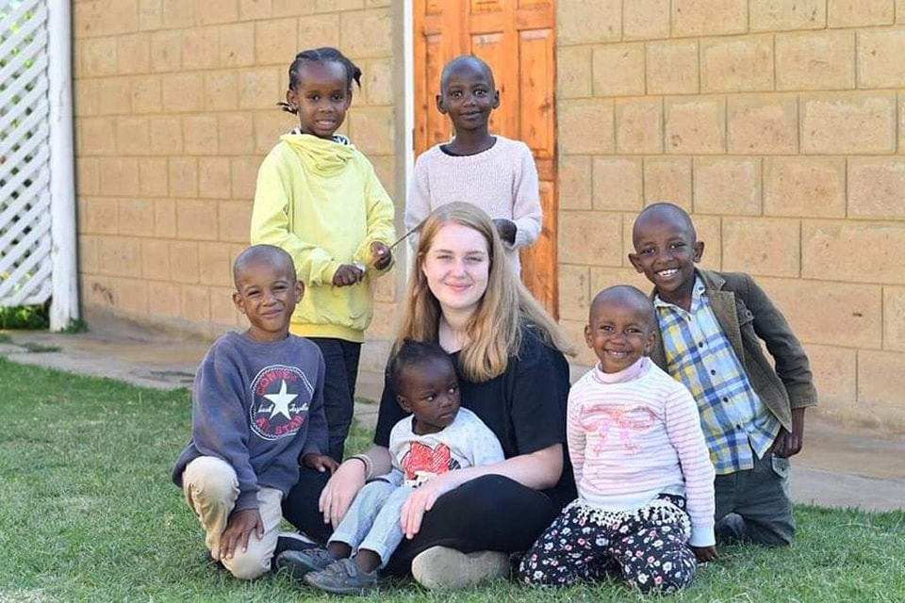
Lastly, enjoy your stay at Restart Africa. Have fun, learn lots and make sure to have the time of your life. We can promise you now, once you have been to Restart you will find it hard to stay away…

